[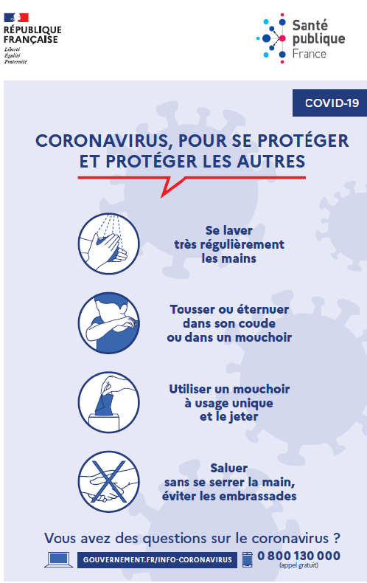](https://www.google.fr/url?sa=i&url=http%3A%2F%2Fwww.iledefrance.ars.sante.fr%2Fcoronavirus-covid-19-eviter-la-propagation-du-virus&psig=AOvVaw2Pr-yg8XqWJuku4dh6-KWW&ust=1584432825336000&source=images&cd=vfe&ved=0CAIQjRxqFwoTCJiZ-6_GnugCFQAAAAAdAAAAABAE)